FACEBOOK POSTING
Zamhari Alparizhi at Provinsi Kep. Bangka Belitung.
December 11, 2017 · Pangkalpinang, Indonesia ·
AIESECER ZAMHARI ALPARIZHI & LESLIE DENNIS-RIGNEY

Pangkalpinang, December 11st 2017
Good morning in Indonesia 🇮🇩 time for Leslie Dennis-Rigney in 🇺🇸, hopefully you are very fine all the time and I am too. Do you still remember the video and the pictures? It was a great 👍 moment for me cause I met the senior AIESECER from America last October 2017. I was happy to hear about your great experiences be a AIESECER in the world 🌎 at the mangrove forest of Kurau Barat at The central of Bangka in Indonesia 🇮🇩,
I will be waiting for you, families and friends to come to my beautiful island of the Bangka Belitung in Indonesia 🇮🇩,
A beautiful moment with The Central of Bangka Indonesia 🇮🇩 Red Cross!!!
My best regards,
Zamhari Alparizhi the junior AIESECER at Bangka Belitung (my WhatsApp +62 812 7835 39)

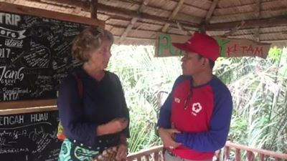
Zamhari Alparizhi posted this above video to his timeline, December 11, 2017. https://www.facebook.com/zamhari.achmadon/videos/1578665965514756/?hc_ref=ARTWa7VAOSRvpY2-Y-Mw6ugiy-eoN1hDUlTrmGjOVSgcGk2lvGNiYgalEHtEDBdlvfY
